Metadata-Driven File Ingestion in SSIS
Load any delimited file with one package, one config table, and no AI in the run path

Problem statement
AI is everywhere right now, and we were asked to use it to automate file loading: point a model at an incoming file and let it work out how to load it.
Before saying yes, we looked at what the work actually is. In almost all warehouse ETL work the flow is the same: structured files arrive, they are loaded into a staging area, the data is processed and transformed, and the result is extracted for analysis. The two ends of that flow, loading and exporting, handle files with a known structure: a delimiter, a header or a fixed list of fields, and a predictable file name. Structure like that can be described once and automated with ordinary code.
So the question we set out to answer is: if loading structured files can be done with simple, deterministic code, why pay for AI to do it?
This post shows how we automated the load side with one SSIS package driven by a config table, and why that was the better choice.

The problem
In most ETL teams, every new inbound file means a new SSIS package: a Flat File Source, a column mapping, a destination, a deployment. We built more than 700 packages that way. They work, but each new feed costs days, and when a client adds or reorders a column the package breaks.
Our goal was simple: add a new feed by inserting one row into a config table, with no new package and no redeployment.
The requirements we set:
- File path, naming convention, delimiter, header flag, and field count live in a SQL Server config table.
- The package receives only two inputs: a feed name and a file date.
- It finds the file, validates its structure, creates the staging table on the fly, and loads every column as a string.
- It refuses to process the same file twice, and it logs every run.

Why we did not use AI to process the files
It is tempting to hand each file to an AI model and ask it to read the file and load it. Most warehouse ETL work starts with structured files that follow a known layout, and for those files a model is the wrong tool, for five reasons.
1. Cost scales with data volume, not difficulty. Models bill per token. A file with millions or billions of records turns into billions of tokens, and that is before output tokens, retries, and the next day's file. The same file loads through SQL Server's BULK INSERT, on a server we already license, at almost no marginal cost. Pricing varies by model and changes over time, but the shape of the curve does not: model cost grows with every row, code cost does not.
2. The problem is deterministic. Is the delimiter a pipe? Is there a header? Does the field count match? Twenty lines of code answer these identically on every run. A model that is almost always right would still get some rows wrong, and at millions or billions of records even a tiny error rate means a large number of bad rows, with nothing to tell you which ones.
3. Speed. BULK INSERT streams data from disk straight into the table at hundreds of thousands to millions of rows per second. A round trip to a model for every chunk of data is orders of magnitude slower.
4. Auditability and data protection. With plain code, customer data never leaves the database environment, every step is reproducible, and a failure can be debugged by reading a SQL statement. Sending production data to an external service adds a review and compliance burden that a bulk load does not need.
5. Operations. SQL Agent, the SSISDB catalog, and standard alerting already run this. There is no new vendor, quota, or outage to plan around.
Where AI does earn its place: unstructured sources such as scanned invoices or free-text emails, exploring an unknown file's layout once, and drafting code, documentation, and test data at design time. In each case the cost is paid once, and what runs in production is deterministic code. Our rule of thumb: use AI to help build the pipeline, not to run it on every row.

Architecture at a glance
The control flow has six tasks, run in order:
- Execute SQL Task reads the feed's row from the config table.
- Script Task builds the real file name from the pattern and the date, and checks that the file exists.
- Execute SQL Task checks the audit table. If this file was already loaded successfully, the run stops.
- Script Task reads the first row, validates the field count, and builds the staging DDL and the load SQL.
- Execute SQL Task creates the staging table, then loads the file with BULK INSERT.
- Execute SQL Task writes the audit row. A package-level OnError handler writes a FAILED row.
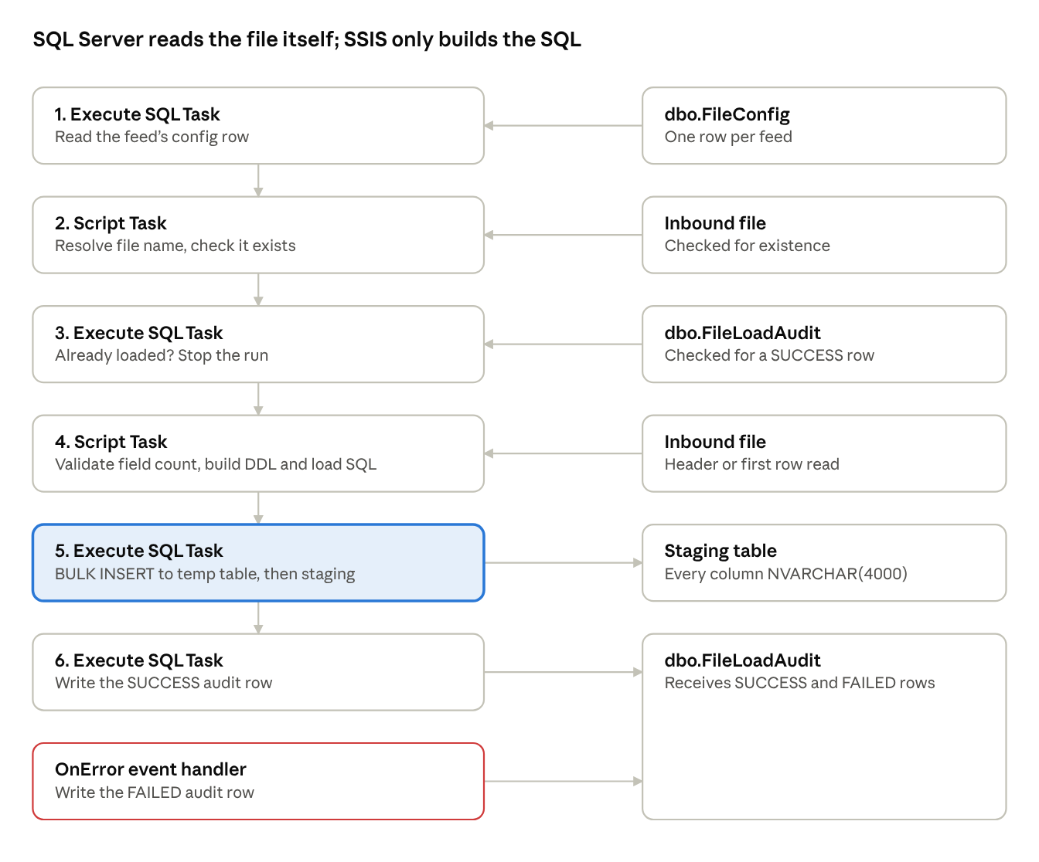
load control flow · 6 tasks, 6 data stores
Steps 1 to 4 only read config and the first row of the file. Step 5 is where the data moves, and it moves inside SQL Server.
Why no Data Flow Task? A data flow has fixed column metadata, decided at design time. A different column count on every run is exactly what it cannot handle, so the dynamic part lives in Script Tasks that generate SQL text.

The config table
One row per feed:
CREATE TABLE dbo.FileConfig (
ConfigId INT IDENTITY PRIMARY KEY,
FeedName VARCHAR(100) NOT NULL UNIQUE,
FilePath VARCHAR(500) NOT NULL,
FileNamePattern VARCHAR(200) NOT NULL, -- CUSTOMER_{yyyyMMdd}.csv
Delimiter VARCHAR(10) NOT NULL, -- ',' or '|' or 'TAB'
HasHeader BIT NOT NULL,
FieldCount INT NOT NULL,
FieldNames VARCHAR(MAX) NULL, -- used when HasHeader = 0
StagingSchema SYSNAME NOT NULL DEFAULT 'stg',
StagingTable SYSNAME NOT NULL,
ArchivePath VARCHAR(500) NULL,
IsActive BIT NOT NULL DEFAULT 1
);
The package takes two parameters: FeedName and FileDate. Everything else comes from this table.

How each step works
Resolving the file name. The pattern holds date tokens in braces, such as CUSTOMER_{yyyyMMdd}.csv. A small regular expression replaces each token with the formatted date, so one config row serves every day.
Validating structure. The rule is the one we wrote down on day one:
- If the file has a header, the header's field count must equal FieldCount, and the header supplies the column names.
- If it has no header, the names come from FieldNames in the config, their count must equal FieldCount, and the first data row must have the same number of fields.
Column names are sanitized: unsafe characters become underscores, empty names become Col1, Col2, and duplicates get a numeric suffix.
Creating the staging table. The script generates a CREATE TABLE with every column as NVARCHAR(4000) NULL. Staging holds strings only. Type conversion happens in the later transformation steps, where bad values can be handled with business rules instead of failing the load.
Skipping files already processed. A single query asks the audit table whether a SUCCESS row exists for this feed and file. Precedence constraints with expressions route the package either to the load or to a stop task. A filtered unique index on the audit table enforces the same rule in the database, so two simultaneous runs cannot both succeed.

The load itself: why BULK INSERT
Our first version read the file inside the Script Task with a text parser and pushed batches of rows through SqlBulkCopy. It was correct, and fine for a few million rows. With millions or billions of records the bottleneck is obvious: one thread parsing and copying row by row in managed code.
The fix was to stop moving the data through SSIS at all. The Script Task now only builds a SQL statement, and SQL Server reads the file itself:
IF OBJECT_ID(N'tempdb..#FileLoad') IS NOT NULL DROP TABLE #FileLoad;
CREATE TABLE #FileLoad (
[CustomerID] NVARCHAR(4000) NULL,
[FirstName] NVARCHAR(4000) NULL,
[LastName] NVARCHAR(4000) NULL,
[City] NVARCHAR(4000) NULL,
[Country] NVARCHAR(4000) NULL
);
BULK INSERT #FileLoad
FROM 'E:\Data\inbound\CUSTOMER_20261020.csv'
WITH (FORMAT = 'CSV', FIELDQUOTE = '"', FIRSTROW = 2,
TABLOCK, BATCHSIZE = 1000000, MAXERRORS = 0);
INSERT INTO stg.Customer WITH (TABLOCK) (CustomerID, FirstName, LastName, City, Country)
SELECT CustomerID, FirstName, LastName, City, Country FROM #FileLoad;
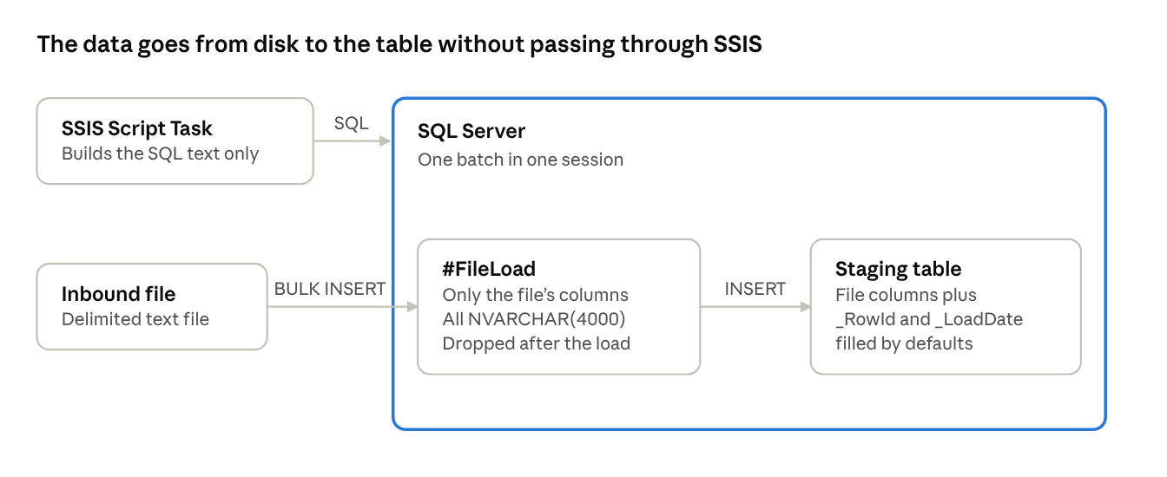
load data path · file to temp table to staging
The Script Task sends only a SQL batch. SQL Server reads the file, fills the temp table, and copies the rows into staging.
The generated statement loads into a temporary table that has only the file's columns. BULK INSERT maps fields to columns by position, so loading directly into a staging table with extra columns (a row id, a load date) fails with a conversion error on the first extra column. Loading into the temp table first, then inserting with an explicit column list, lets the staging table keep its housekeeping columns.
Because the whole statement runs as one batch in one Execute SQL Task, the temp table lives for the entire load. The row count is read back from the INSERT and written to the audit table.
The result: the data moves from disk into SQL Server without passing through the SSIS process, and load speed is limited by storage and the database, not by our code.

Gotchas we hit, and how we fixed them
- NULL into a String variable. An Execute SQL Task cannot map a VARCHAR(MAX) column into a String variable and reports DBNull, even when the value is not null. Cast long config columns to VARCHAR(8000) in the query.
- Two SqlClient providers. An ADO.NET connection manager created with Microsoft.Data.SqlClient fails a cast to System.Data.SqlClient.SqlConnection. Casting to the common base class, DbConnection, works with either.
- Error 7301, IID_IColumnsInfo. A generic message from the BULK provider. We found the real cause by testing in steps: file visible to the server (xp_fileexist), file readable (OPENROWSET), then a minimal BULK INSERT. It turned out to be extra columns in the staging table.
- File path visibility. BULK INSERT reads the file on the SQL Server machine, using the SQL Server service account. A path that exists only on the SSIS machine, or a mapped drive letter, fails. Use a local path on the server or a UNC share.
- Copied tasks keep old variables. Copying the OnError handler from another package left it pointing at variables that did not exist. The handler failed and hid the original error. Always re-map parameters after copying tasks.

Advantages
- One package for every delimited feed. A new feed is an INSERT into the config table, tested the same day.
- Cost. No per-row or per-token charges, no new vendor, no extra licensing.
- Speed. Server-side BULK INSERT with minimal logging scales to millions and billions of rows.
- Predictable and auditable. The same input gives the same result, every run is in the audit table, and the generated SQL can be inspected and replayed.
- Safe by default. Structure is validated before anything is loaded, a duplicate file stops the run, and any failure is recorded.
- Data stays put. Files are read by the database server, with no external service in the path.
- Maintainable. Support staff change behavior through config rows, and developers maintain one codebase instead of hundreds of packages.

Limitations and next steps
- All staging columns are strings, so typing and validation move to the next layer.
- The temp-table hop writes the data twice and needs tempdb space. A regular work table is a drop-in alternative.
- FORMAT = 'CSV' needs SQL Server 2017 or later.
- Fixed-width and multi-record-type files need their own parser. The config approach still applies.
- Reject handling today is all-or-nothing (MAXERRORS = 0). An error file and a reject threshold are the natural next step.

Conclusion
Most ETL work is structured, repetitive, and rule-bound. That is the profile where ordinary code is cheapest, fastest, and easiest to trust. By putting the file's description in a config table and letting a small amount of generated SQL do the heavy lifting, we replaced a pile of one-off packages with a single loader. AI remains a useful assistant while building such a framework. It does not need to be in the loop for every row that runs through it.

